TEAM1

Ajit Ghising(leader)

Dipendra Poudel

Dawa Zangmu Sherpa

Dinesh Aryal

Project Handbook

S2-18 VR Energising Experience (Liminal VR)

This template is loosely based on the following standards:

* Australian Standard AS4071-1992(R2014) - Software project management plans
* AS/NZS ISO/IEC/IEEE 42010:2013 – Systems and software engineering – Architecture description

Note that following this template is not enough to claim conformance to either of the above standards! For Project courses, some sections have been excluded completely, and some are optional. These are noted, and may be skipped

# Revision

*Use whichever style of versioning you prefer.*

*You may also include the main authors of each change, and the list of pages that have been changed*

|  |  |  |  |
| --- | --- | --- | --- |
| Version Number | Date approved | Approved by | Description |
| 1.0 | 2019-09-01 | Team1 | First iteration of the project |
| 2.0 | 2019-09-22 | Team1 | Second iteration of the project |

# Preface

This document includes the major roles of the organization and the people involved in this project; the major requirements of the project and how these requirements are deal with the iteration and the minutes of meeting of the team working on it. The experience is to be designed for Oculus Go. We need to integrate the points of interactions with the use of controller’s trigger or touch surface as inputs. This project relies heavily on UX, so we are advised to conduct a UX testing at the end of each sprint using proper testing techniques. The learning from the UX testing, should be incorporated in next sprint of development*.*

Table of Contents

Revision 1

Preface 1

List of Figures 3

List of Tables 5

1. Introduction 6

1.1 Project Overview 6

1.2 Project Deliverables 6

1.3 Evolution of the Handbook 6

1.4 Reference Materials 6

1.5 Definitions and Acronyms 6

2. Organization 6

2.1 Process Model 6

2.2 Organizational Structure 9

2.3 Organization Boundaries and Interfaces 10

2.4 Project Responsibilities 14

3. Managerial Process 15

3.1 Management Objectives and Priorities 15

3.2 Assumptions, Dependencies, and Constraints 16

4. Technical Process 16

4.1 Methods, Tools, and Techniques 16

4.2 Software Documentation 18

5 Non-functional Requirements 18

5.1 Platform 18

5.2 Usability 19

5.3 Performance 19

5.6 Reliability 19

5.7 Modifiability 19

5.8 Economic 19

5.9 Legal 19

6 Software and Systems Architecture 19

6.1 Architecture objectives 19

6.2 High-level architecture 20

6.X User Interface / Interaction Design 20

6.X Data model and software design 21

6.X Assumptions 22

6.X External Dependencies 22

6.X Concept art, storyboards 23

Additional Components 24

*https://liminalvr.com/liminal-platform/* 24

Appendices 24

**MEETING AGENDA** 24

# List of Figures

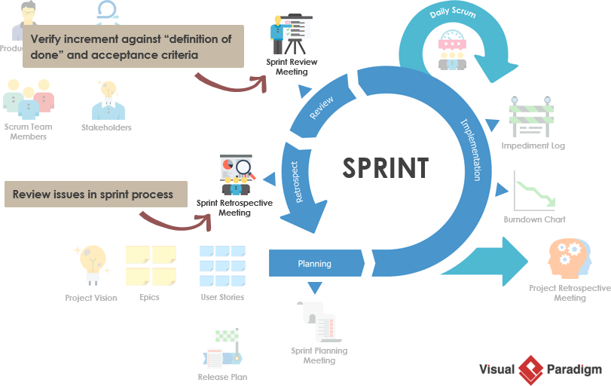

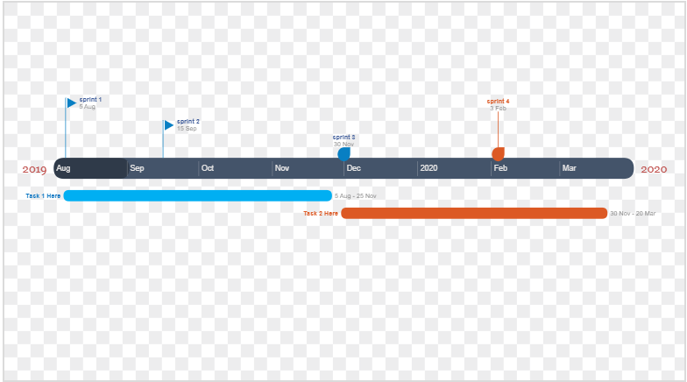

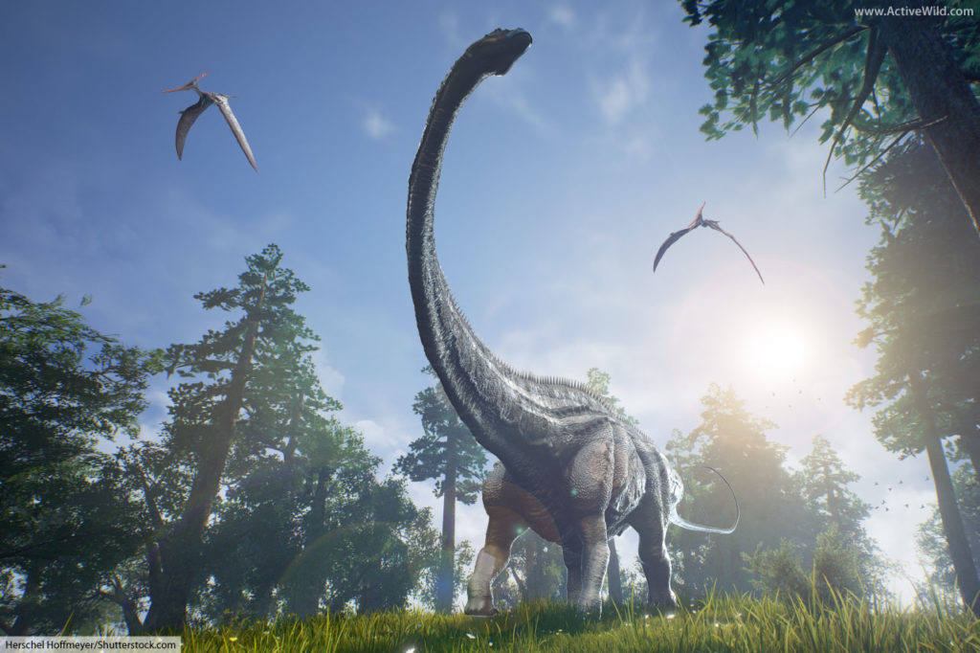

# List of Tables

|  |  |  |  |  |  |  |
| --- | --- | --- | --- | --- | --- | --- |
| **Meeting Type** | **Length** | **First Meeting** | **Frequency** | **Number of Planned Meetings** | **Location/Mode** | **Objective** |
| **Team Meeting** | 12pm to 2pm | Friday  30th July  2019 | Weekly | 1 | ATMC | Group formation & Discussion |
| **Client Meeting** | 10am to 11Am | 07/08/2019 | Bi-weekly | 2 | Atmc lab | Discuss about requirement of the project |
| **Client Meeting**  **(Week 3)** | 10am to 11am | 07/08/2019 | Weekly | 4 | ATMC Druitt Street | Chat over phone by Damian |
| **Client Meeting**  **(Week 5)** | 10am to 11am | 11/08/2019 | Weekly | 6 | Atmc room 4 | Gathering of group and discussion of requirement |
| **Client Meeting**  **(Ongoing)** | 12am to 2pm | 20/08/2019 | Weekly | 13 | ATMC | Requirement and need for luminal VR |

# 1. Introduction

## 1.1 Project Overview

## 1.2 Project Deliverables

This document includes the major roles of the organization and the people involved in this project; the major requirements of the project and how these requirements are deal with the iteration and the minutes of meeting of the team working on it. The experience is to be designed for Oculus Go. We need to integrate the points of interactions with the use of controller’s trigger or touch surface as inputs. This project relies heavily on UX, so we are advised to conduct a UX testing at the end of each sprint using proper testing techniques. The learning from the UX testing, should be incorporated in next sprint of development.

## 1.3 Evolution of the Handbook

* *Please refer to the appendices.*

## 1.4 Reference Materials

<https://whatis.techtarget.com/definition/virtual-reality>

<https://www.eturbonews.com/174015/role-virtual-reality-education/>

## 1.5 Definitions and Acronyms

|  |  |
| --- | --- |
| Term | Definition |
| VR | Virtual Reality |
| UX | User Experience |

# 2. Organization

## 2.1 Process Model

We are the students of the federation university, currently studying in ATMC campus Sydney. We are assigned to develop VR experience for student where they are going to fell energetic to stay on test.

This project relies heavily on user experience, so we are advised to conduct a UX testing at the end of each sprint using proper testing techniques. The learning from the UX testing, should be incorporated in next sprint of development

We have chosen calm experience for the liminal VR project where calm state is identified as an emotional and cognitive demission i.e. Jurassic world. the calm experience that we choose to create for the liminal platform is aimed to be around 3 minutes or less in length where the environment is the Jurassic world and the user calming experienced are passive in nature.

We are going through a passive approach, users should be sitting or lying still because passive VR is well suited for deep relaxation purposes users need to do so. The key of this experience is constant progression and evolving content by maintain the engagement with users in experience. for this we are implementing “nature “which is one of the calm principals and technic.as it is the passive experience (Jurassic world) both real and digital interaction with this Jurassic nature can be extremely beneficial for refreshment, stress relief also reduce cognitive fatigue.

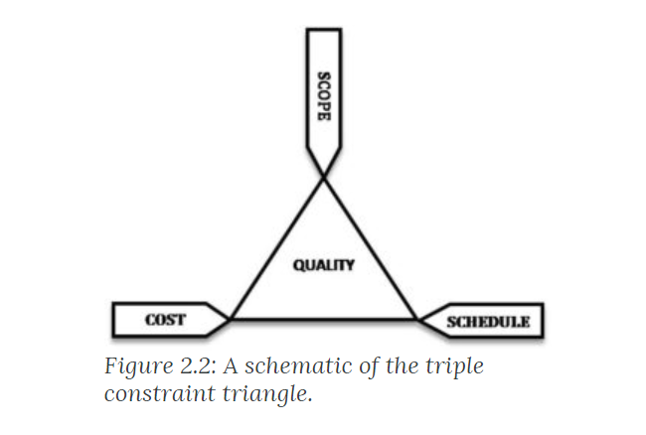

**WORK BREAKDOWN STRUCTURE**

|  |  |  |  |
| --- | --- | --- | --- |
| **PROJECT TITLE** | **Energizing Experience (Liminal VR)** | **COMPANY NAME** | Liminal VR |
| **PROJECT MANAGER** | Wallyat Hussain | **DATE** | 01-09-2019 |

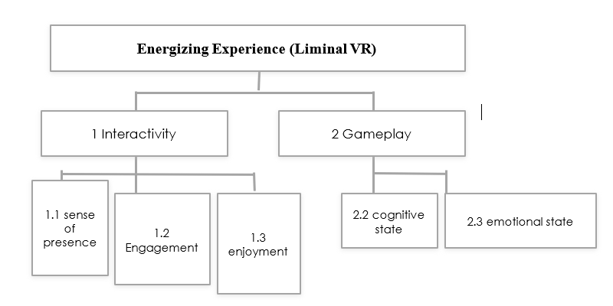

**Project plan timeline**



**Sprint review chart**



## 2.2 Organizational Structure

The above figure shows the team structure of the project team where Damian Moratti is the CEO and co-founder of Liminal. He is an entrepreneur with almost a decade of experience starting and running I.T. support and eMarketing businesses. The whole communication in this project is done with him about the functional and non-functional requirements of the Liminal.

Walayat Hussain is our project supervisor who supervise us what things need to be focused and submitted in respective time and provides all the resources and tools needed in this project.

Team1 is the name of the team where Ajit Ghising (Team leader) leads the team in a pace so that the project requirements are finished on time and Dawa Zagmu Sherpa, Dipendra Poudel and Dinesh Aryal are the member of this team who helps to finish this project.

## 2.3 Organization Boundaries and Interfaces

GitHub Communication

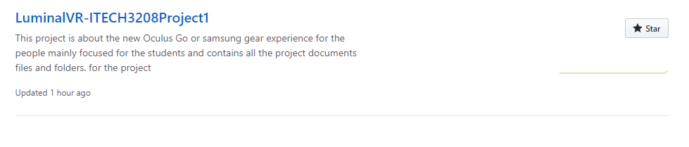

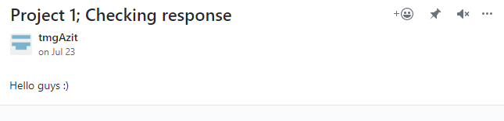

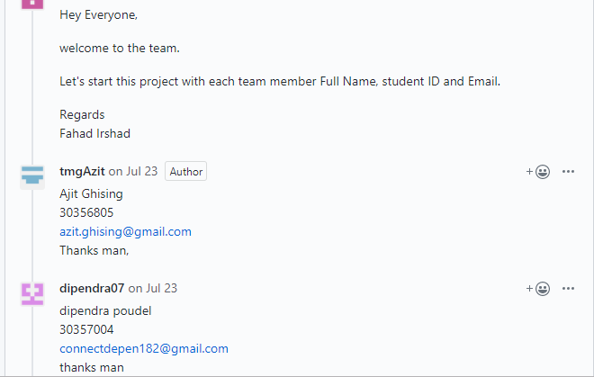

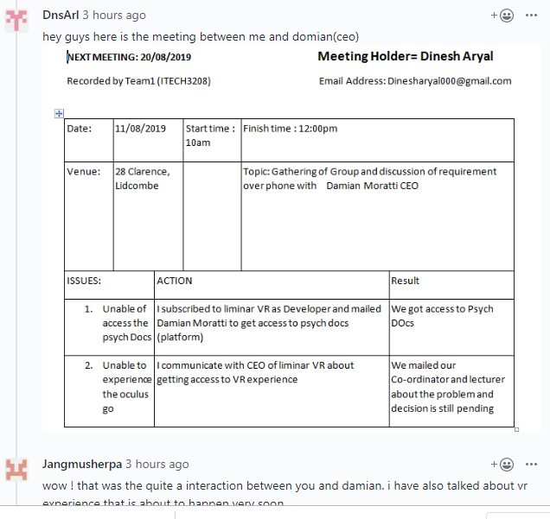

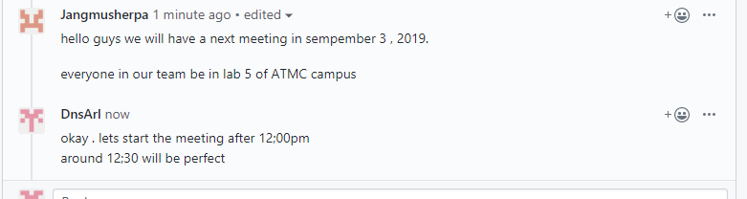

As our team have done a lot of communication and discussion through GitHub but the platform did not allow us to share the files so we use social media and e-mail (Facebook and Gmail) to share the files.

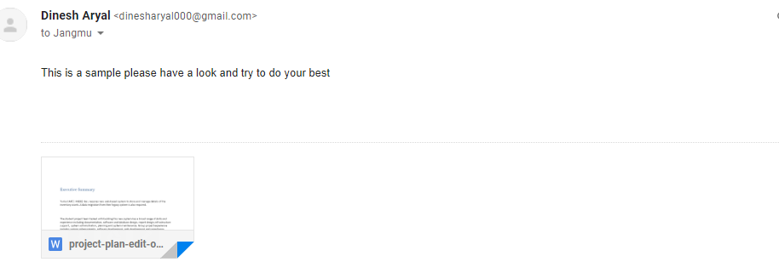

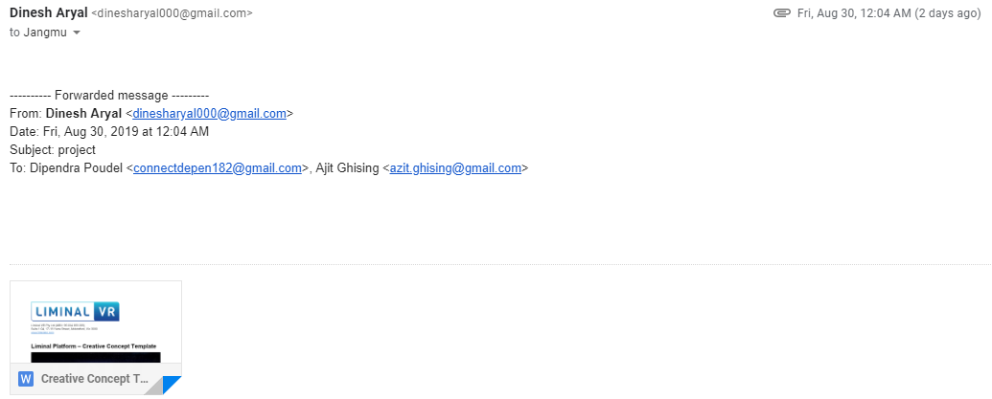

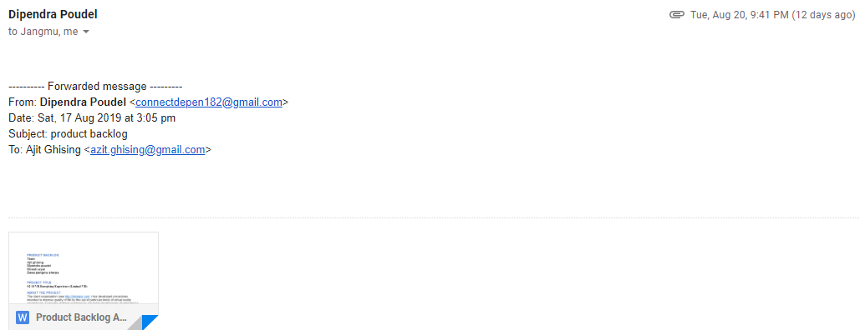

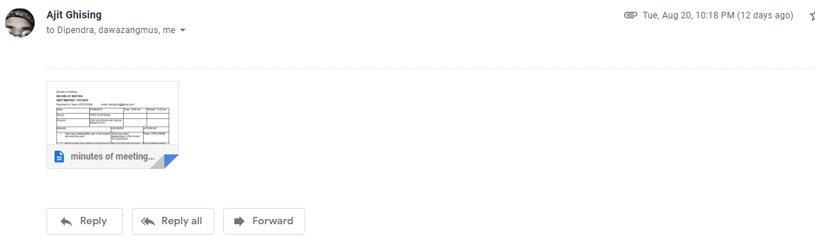

I Have a communication with the CEO of liminal VR and had a response back.

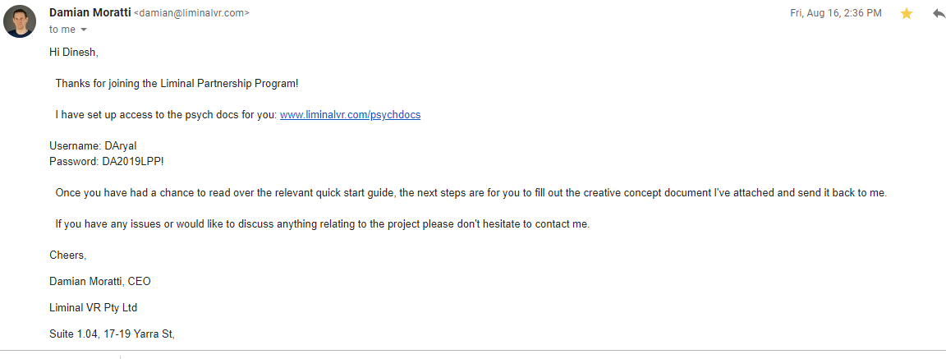

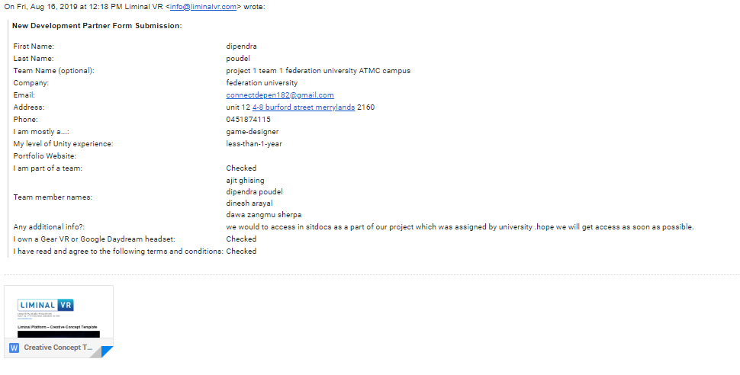

Meeting times

|  |  |  |  |  |  |  |
| --- | --- | --- | --- | --- | --- | --- |
| **Meeting Type** | **Length** | **First Meeting** | **Frequency** | **Number of Planned Meetings** | **Location/Mode** | **Objective** |
| **Team Meeting** | 12pm to 2pm | Friday  30th July  2019 | Weekly | 1 | ATMC | Group formation & Discussion |
| **Client Meeting** | 10am to 11Am | 07/08/2019 | Bi-weekly | 2 | Atmc lab | Discuss about requirement of the project |
| **Client Meeting**  **(Week 3)** | 10am to 11am | 07/08/2019 | Weekly | 4 | ATMC Druitt Street | Chat over phone by Damian |
| **Client Meeting**  **(Week 5)** | 10am to 11am | 11/08/2019 | Weekly | 6 | Atmc room 4 | Gathering of group and discussion of requirement |
| **Client Meeting**  **(Ongoing)** | 12am to 2pm | 20/08/2019 | Weekly | 13 | ATMC | Requirement and need for luminal VR |

## 2.4 Project Responsibilities

# 3. Managerial Process

## 3.1 Management Objectives and Priorities

Management philosophy is a set of beliefs or rules used by managers to help them make decisions. It looks simple enough, but remember that this is also philosophy, and that means there’s always another layer (don’t worry, I won’t answer you with a question). The extra layer refers to the meaning or reason as to why you would choose to use those rules. This is important because it provides a powerful sense of purpose and motivation. A good management philosophy gives direction and cohesion to the organization.

When used effectively, virtual reality can be invaluable as a learning tool due to a concept cognitive researcher refer to as “presence.” Presence, in the sense of VR, refers to the notion that in many ways, VR feels so real that the brain responds as if it was an actual experience. Because of this, VR opens numerous avenues for workplace training to which previous classroom or seminar training models simply cannot compare. If we really want to experience what it’s like to be on a study line, or to be dealing with a sleepy student, we can’t get any closer to the actual experience than when it takes place in an immersive learning environment. Using a virtual reality headset, one could simulate almost any type of situation – say, lunch rush at a busy deli, a department store during the holiday shopping season, or the inside of an airplane hangar – without ever having to physically leave the room. VR provides safe access to risky, hard to replicate situations in the comfort of a conference room our desk. One of the most powerful tools when creating VR-based immersive learning environments is the ability to capture unique data and analysis it to continuously improve the training experience. We can, for example, capture the responses learners make during the experience, track head movements to determine which areas they focus on, and measure the rate at which they progress and complete tasks.

In aggregate, these insights allow for unmatched performance analysis and insights for improvement. The VR experience provides unique and important metrics that provide an unprecedented look into the mind of a learner, enabling educators to see how well trainees are learning, as well as explore where additional training is needed or where lessons should be improved.

Conflict is a normal part of any healthy relationship. After all, two people can’t be expected to agree on everything, all the time. The key is not to avoid conflict but to learn how to resolve it in a healthy way. When conflict is mismanaged, it can cause great harm to a relationship, but when handled in a respectful, positive way, conflict provides an opportunity to strengthen the bond between two people. Whatever the cause of disagreements and disputes, by learning these skills for conflict resolution, you can keep your personal and professional relationships strong and growing.

Conflict arises from differences, both large and small. It occurs whenever people disagree over their values, motivations, perceptions, ideas, or desires. Sometimes these differences appear trivial, but when a conflict triggers strong feelings, a deep personal need is often at the core of the problem. These needs can range from the need to feel safe and secure or respected and valued, to the need for greater closeness and intimacy.

Conflict triggers strong emotions and can lead to hurt feelings, disappointment, and discomfort. When handled in an unhealthy manner, it can cause irreparable rifts, resentments, and break-ups. But when conflict is resolved in a healthy way, it increases your understanding of the other person, builds trust, and strengthens your relationships.

## 3.2 Assumptions, Dependencies, and Constraints

Our project is based on virtual reality experience where our client organisation (see http://liminalvr.com) has developed procedures intended to improve quality of life using kinds of virtual reality experiences. Examples of these experiences are being developed by student teams all around the world. Imagine there’s a big exam on the horizon but the students are feeling sleepy. This project seeks to create an experience to ‘wake’ them up and get them motivated to ace the test! Using the research in the Liminal Psych Docs to be provided by the client, design an experience which will enhance their energy levels and be fun and invigorating. The client is available for consultation and will provide feedback on the quality of the work, communicating via Slack. The experience is to be designed for Oculus Go. Students need to integrate the points of interactions with the use of controller’s trigger or touch surface as inputs.

This project relies heavily on UX, so students are advised to conduct a UX testing at the end of each sprint using proper testing techniques. The learning from the UX testing should be incorporated in next sprint of development. There are various external events and input that our project is depend on. We are developing our project as a partner liminal company. This company provide us the platform to develop our project. All the functional and non- functional requirement of the project is provided by liminal. Oculus Go is another platform for the experience of our project. Students need to integrate the points of interactions with the use of controller’s trigger or touch surface as inputs. This project relies heavily on UX, so students are advised to conduct a UX testing at the end of each sprint using proper testing techniques. We planning to finish our project by next semester, and we will handover to our client. Our project is operating under the supervision of Damian Moratti(CEO) of liminal and our lecturer Wallyat Hussain. We are four team members in our group.one of the team member will lead our team. All the budgetary things will manage by our campus. We using Oculus GO platform to develop our project.

# 4. Technical Process

## 4.1 Methods, Tools, and Techniques

On the software development phase for our liminal virtual reality , we will be using object oriented software engineering (OOSE). This design methodology will use ‘use case diagrams’ which includes requirement, analysis, design, implementation and testing model.

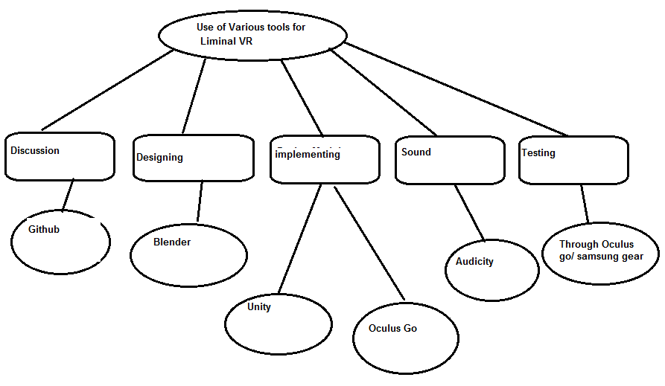

For this project we are going to use various development tools which will result in the succeeding of our Liminal VR project, which not only includes the Virtual reality video that exciting but it’s also going to make viewer energetic.

For Jurassic world project, we are going to use various software:

* GitHub: As we know that GitHub is a development platform We are going to use GitHub to upload the activity and review the work we teammates are doing as well to manage the project we are working on.

Overall, we are going to use this platform to look over the progress and drawback of the project and try to eliminate it.

* Blender: Blender is going to play a very big role in our project. It will be widely used by our team to make various things in Jurassic world. As we have described earlier about the dinosaurs, sunbeams, tree and visual forest that looks like reality when looked over it by using virtual reality device.

Overall, we are going to use blender for creating 3D printed model, Graphic editing, partial stimulation which will help us to make our model into reality i.e. Dinosaurs, Trees, sun and its beams which will be later uploaded into unity.

* Unity: As we know that Unity is ultimate game development platform which is usually used to make 2D as well as 3D games which can not only be deployed into PC and phone but also over VR console so our team has decided to use Unity to make video for our project. Ricky and Morty, Ori and the Blind forest is quite popular video as well as game so seeing that we got a influence and decided to make our Jurassic world video over it.

Hence, the model we will made over the Blender i.e. Dinosaurs, trees, bushes as well as sun will be uploaded over it and we will do coding to make the functionality work intuit.

* Audacity: We are going to use Audacity to performs various number of audio editing tasks such as to make music that will put a life into the Jurassic world project. That will make views to feel like they are inside that video they are looking and feel them energetic.

Overall use of this various platforms will help us to get our project to be successful, we will have a environment which is fully being in a nature as provide the viewer refreshment as well as energetic.

## 4.2 Software Documentation

Overall information about the Product and Process documentation including design and architecture, source code, verification, testing and maintenance guide is kept for future analysis of the Virtual reality if needed. Moreover it helps the user to know how the Liminal Virtual reality operates or how to use it.

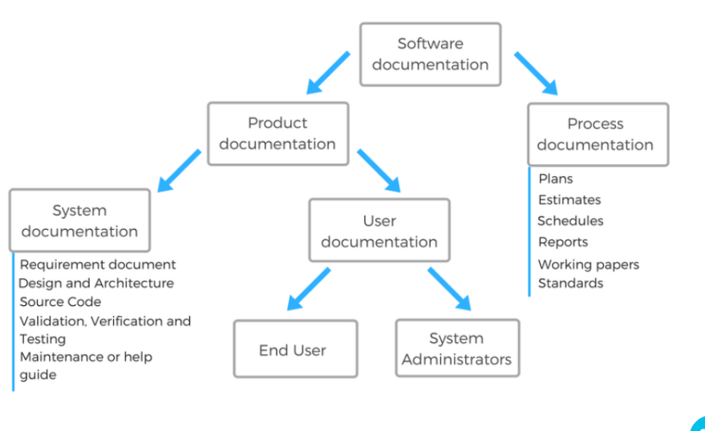

Figure 11 software documentation for Liminal Virtual Reality

# 5 Non-functional Requirements

According to the project there is two types of requirements that is functional and non-functional requirements. A non-functional requirement is a requirement that specifies criteria that can be used to judge the operation of a system, rather than specific behaviours. They are contrasted with functional requirements that define specific behaviour or functions. On-functional requirements are based on functional requirements such as**:**

## 5.1 Platform

* Oculus go is used as Hardware environment
* Blender, Unity, Audacity, and GitHub are the software environment

## 5.2 Usability

* System need to be easy to use by every stakeholder and the user.
* Learn display and control button with logically set for the user and stakeholder itself.

## 5.3 Performance

* There is not down time expected.
* Speedy
* System need to be in real time management
* System can inform to user if they are doing something wrong when entry the data.
* The calculation formula needs to be strong relationship with product items.

## 5.6 Reliability

* The system needs to be accuracy and trustful, if there is any threshold can cause a lot of code to fix as coding is very necessary for our project.
* Different passwords are set for every level of team member, client and the CEO of the project to make it more secure.

## 5.7 Modifiability

* Firstly, we need to change the coding and update in Unity
* Secondly, we need to do testing in Blender before finalizing
* Lastly, we can finalize in Oculus Go and modify it

## 5.8 Economic

* Advanced virtual reality i.e. Oculus Go which is hard to afford
* Blender and unity are one of the popular and expensive tools for the project
* Audacity is one of the expensive materials as well.

## 5.9 Legal

* Licensed the software via IT government
* Got permission from the university to experience the virtual reality*.*

# 6 Software and Systems Architecture

## 6.1 Architecture objectives

As we are creating the experience for the liminal VR, there are different properties depending on the requirements i.e. functional and non-functional. These different properties are the platform, usability, reliability, performance, legal, modifiability and economic which are met to aim for the same goal that is creating Jurassic experience.

## 6.2 High-level architecture

For this project we are going to use various development tools which will result in the succeeding of our Liminal VR project, which not only includes the Virtual reality video that exciting but it’s also going to make viewer energetic.

For Jurassic world project, we are going to use various software:

* GitHub: As we know that GitHub is a development platform, we are going to use GitHub to upload the activity and review the work we teammates are doing as well to manage the project we are working on.

Overall, we are going to use this platform to look over the progress and drawback of the project and try to eliminate it.

* Blender: Blender is going to play a very big role in our project. It will be widely used by our team to make various things in Jurassic world. As we have described earlier about the dinosaurs, sunbeams, tree and visual forest that looks like reality when looked over it by using virtual reality device.

Overall, we are going to use blender for creating 3D printed model, Graphic editing, partial stimulation which will help us to make our model into reality i.e. Dinosaurs, Trees, sun and its beams which will be later uploaded into unity.

* Unity: As we know that Unity is ultimate game development platform which is usually used to make 2D as well as 3D games which can not only be deployed into PC and phone but also over VR console so our team has decided to use Unity to make video for our project. Ricky and Morty, Ori and the Blind forest is quite popular video as well as game so seeing that we got a influence and decided to make our Jurassic world experience over it.

Hence, the model we will made over the Blender i.e. Dinosaurs, trees, bushes as well as sun will be uploaded over it and we will do coding to make the functionality work into it.

* Audacity: We are going to use Audacity to performs various number of audio editing tasks such as to make music that will put a life into the Jurassic world project. That will make views to feel like they are inside that video they are looking and feel them energetic

## 6.X User Interface / Interaction Design

We have chosen clam experience for the liminal VR project where clam state is identified as an emotional and cognitive demission i.e. Jurassic world. the clam experience that we choose to create for the liminal platform is aimed to 3 minutes in length where the environment is the Jurassic world where the user calming experienced are passive in nature.

For VR (virtual reality) to contain gameplay features, users must be able to interact and control elements of virtual environments which enable them to win or lose. In contrast, interactive experiences don’t require any gameplay components to function. User interactions can simply exist as joyful novel actions, as opposed to functions which help to complete goals or missions.

## 6.X Data model and software design

A Work Breakdown Structure, Gannt chart and Milestone plan have been created to outline project tasks and the expected timelines.



Fig: Work Breakdown Structure

The interactive nature of VR will continue to be a standout feature which enhances the sense of presence, engagement and enjoyment an experience can provide. Even so, passive VR experiences with no obvious form of gameplay or participation can still effectively induce cognitive and emotional states. They encourage users to take better notice of surrounding audio/visual stimulation; features which are easily overlooked when engaged in demanding tasks in VR. As such, interactivity and gameplay are not essential to all experiences within the Liminal VR platform. The following sections looking at considerations for gameplay and gaze control, as well as restrictions for interactivity, outline factors significant to all categories of the platform. The final sections include research evidence and examples relevant to specific categories.

**Interactivity**: The physical input which enables participation and the extent to which a user has influence over a virtual environment.

**Gameplay**: The incorporation of goals or objectives which define how users should interact.

Overall use of this various platforms will help us to get our project to be successful, we will have an environment which is fully being in a nature as provide the viewer refreshment as well as energetic. i.e. more detailed description of the experience – embedded images such as a storyboard are encouraged but not mandatory.

Sound and interactivity should be carefully considered as part of the creative concept outline.

## 6.X Assumptions

In today’s world, everything is about the technology and it is getting very popular day by day. Every single day technology comes up with some new idea to make human life easier and faster. VR is one of the most popular technology to experience something new in life and the other thing it is totally different form the real world.

Firstly, Virtual reality is an artificial environment that is created with software and presented to the user in such a way that the user suspends belief and accepts it as a real environment. Virtual reality helps students discover how the software can be used in other fields such as medicine, entertainment, and fashion among others. VR assists students with learning and knowledge retention. The technology software allows students to explore and move around their classrooms while learning. So, this seems to be very helpful technology for the students for their motivation and to stay focused in class and avoid distracted which makes students to keep their focus on what they are learning.

On the other hand, virtual reality helps to expand or increase your thinking or imagination. It can lead to experiencing new and exciting discoveries which have an influence on our day to day lives. Moreover, it is indeed beneficial in the educational system. It enables students to easily grasp what they try to understand when being taught by their educators; teachers, lecturers or professors. Virtual reality is applicable in the educational field since it simplifies the learning process for students by bringing their virtual environment to reality.

Therefore, in this scenario, our project will aim to focus on student to maintain their study progress better through VR experience where they are going to fell energetic to stay on test.

## 6.X External Dependencies

We are constantly adding and ranking experiences and will be implementing new categories and features over time. Liminal is an interactive, virtual reality platform designed to empower people just like us, to consciously choose how you’d like to feel and perform. The experiences on the Liminal platform are developed by Liminal VR and our global network of partners, drawing on 5 years of research and development in fields as diverse as neuroscience and psychology, video games, music and cinema. There are currently 4 categories of experiences for us to choose from – Calm, Energy, Awe & Relief.

## 6.X Concept art, storyboards

we are going through a passive approach, users should be sitting or lying still because passive VR is well suited for deep relaxation purposes users need to do so. The key of this experience is constant progression and evolving content by maintain the engagement with users in experience. for this we are implementing “nature” which is one of the clam principals and technic.as it is the passive experience (Jurassic world) both real and digital interaction with this Jurassic nature can be extremely beneficial for relaxation, stress relief also reduce cognitive fatigue. The calming natural element of this Jurassic world contain;

* sun beams shifting through leaf.
* tree branches blowing gently in breeze.
* view of trees and forest
* field dominated with grassland.
* park like forest creek.
* mountain with waterfall or steam.

Our experience contains the above listed natural element on based which the design factor will be 360 (field of view).

The concept design of the experience is shown below:



# Additional Components

# *https://liminalvr.com/liminal-platform/*

<https://whatis.techtarget.com/definition/virtual-reality>

<https://www.eturbonews.com/174015/role-virtual-reality-education/>

# Appendices

## **MEETING AGENDA**

Recorded by Team1 (ITECH3208)             Email Address: dawazangmus@gmail.com

|  |  |  |  |  |  |
| --- | --- | --- | --- | --- | --- |
| Date: | 30/07/2019 | | Start time: 12pm | Finish time: 2 pm | |
| Venue: | ATMC | |  | Topic: Group formation and project discussion | |
| ISSUES: | | Discussion | | | Action by |
| 1. Group formation | | This is the first meeting that we formed our group and choose the topic and we started discussion about the project and further process for the project. | | | Dawa Zangmu Sherpa Team1) |
| 1. Discussion with lecturer | | After choosing the project we started discussing about the project with the lecturer and he explained us how to work on it.  And some more useful tips to work on the project | | | Dawa Zangmu Sherpa |

Recorded by Team1(ITECH3208)             email: connectdepen182@gmail.com

|  |  |  |  |  |  |
| --- | --- | --- | --- | --- | --- |
| Date: | 05/08/2019 | | Time: 10:00 am | | Closed: 11:00 am |
| Venue: | ATMC Druitt Street | |  | |  |
| Present: | Discussion about the requirement of the project. | |  | |  |
| Issues | | DECISION: | | ACTION BY: | |
| 1.What are the functional requirements and the qualities in terms of usability, correctness, efficiency, adaptability and speed? Address the requirements needed to be prioritize at first, if any? | | Sent the email about functional requirement to the CEO (Damian Moratti) | | Team1(ITECH3208 | |
| 2.What are the non- functional requirements and the qualities in terms of security, performance, colour scheme and branding? Address the requirements needed to be prioritize at first, if any? | | Decided to send the email about non-functional requirement to the CEO (Damian Moratti) | | Team1(ITECH3208) | |
| 3.What is the usability? how often it needs to update or modified?  What is the timeline? What are the risks? | | Decided from the group discussion between the group member, client and stakeholder modification, timeline and risk of the project. | | Team1(ITECH3208) | |
| 4. What are the main qualities required? Such as usability, correctness, efficiency, adaptability, speed What are the requirements needed for the project? | | Decided from the group discussion. | | Team1(ITECH3208) | |
| 5.What is the terminology to use? | | GitHub, blender, unity. | | Team1(ITECH3208) | |

**NEXT MEETING: 11/07/2019**

Recorded by Team1(ITECH3208)             email: azit.ghising@gmail.com

|  |  |  |  |  |  |
| --- | --- | --- | --- | --- | --- |
| Date: | 07/08/2019 | | Time: 10:00 am | | Closed: 11:00 am |
| Venue: | ATMC Druitt Street | |  | |  |
| Present: | Chat over Phone with Damian Moratti (CEO) | |  | |  |
| ISSUES: | | DECISION: | | ACTION BY: | |
| 1. How many stakeholders are in this project and who they are? | | There are many stakeholders in the liminal VR department. | | Team1(ITECH3208) | |
| 1. What are the roles of these stakeholders? | | They are the CEO and the head of each departments on specific part. | | Team1(ITECH3208) | |
| 1. What are the functional requirements and the qualities in terms of usability, correctness, efficiency, adaptability and speed? Address the requirements needed to be prioritize at first, if any? | | Gameplay and Interactivity,  Motion,  Visual design | | Team1(ITECH3208) | |
| 1. What are the non- functional requirements and the qualities in terms of security, performance, colour scheme and branding? Address the requirements needed to be prioritize at first, if any? | | Colour, Sound Effect | | Team1(ITECH3208) | |
| 1. Is there any specific methods, tools and techniques needed to be followed in this project? | | Blender and Unity | | Team1(ITECH3208) | |
| 1. Is there any specific terminology needs to be followed? | | No specific Terminology | | Team1(ITECH3208) | |

**NEXT MEETING: 20/08/2019 Meeting Holder= Dinesh Aryal**

Recorded by Team1 (ITECH3208)             Email Address: Dinesharyal000@gmail.com

|  |  |  |  |  |  |
| --- | --- | --- | --- | --- | --- |
| Date: | 11/08/2019 | | Start time: 10am | Finish time: 12:00pm | |
| Venue: | ATMC | |  | Topic: Gathering of Group and discussion of requirement over phone with Damian Moratti CEO | |
| ISSUES: | | ACTION | | | Result |
| 1. Unable of access the psych Docs | | I subscribed to luminal VR as Developer and mailed Damian Moratti to get access to psych docs (platform) | | | We got access to Psych Docs |
| 1. Unable to experience the oculus go | | I communicate with CEO of luminal VR about getting access to VR experience | | | We mailed our Co-ordinator and lecturer about the problem and decision is still pending |

**NEXT MEETING: 27/08/2019**

Recorded by Team1 (ITECH3208)             Email Address: azit.ghising@gmail.com

|  |  |  |  |  |  |
| --- | --- | --- | --- | --- | --- |
| Date: | 20/08/2019 | | Start time: 12pm | Finish time: 2 pm | |
| Venue: | ATMC | |  | Topic: Requirements need for the luminal project. | |
| ISSUES: | | Discussion | | | Action by |
| 1. No access to psych doc and creative template | | We talked to the tutor and coordinator of the ATMC and emailed about the relevant issue to all the related people respectively. | | | Ajit (Team1) |
| 2. No access to oculus Go or Samsung gear and need to experience before starting project. | | We asked to get provide the oculus Go or Samsung gear in order to experience and know how it works as we are creating the new experience targeted to the people, especially students. We are also told to email about it and so we did. | | | Ajit & Dipendra (Team1) |

**NEXT MEETING: 05/09/2019** Meeting Holder= Ajit Ghising

Recorded by Team1 (ITECH3208)             Email Address: azit.ghising@gmail.com

|  |  |  |  |  |  |
| --- | --- | --- | --- | --- | --- |
| Date: | 27/08/2019 | | Start time: 10am | Finish time: 2pm | |
| Venue: | Mirchi restaurant (Townhall) | |  | Topic: Fill up the creative template and submit it. | |
| ISSUES: | | Discussion | | | Action by |
| 1. Got approval for the Luminal VR or Samsung gear by the ATMC. | | We sent an email to the Gaurav (IT in charge) to confirm the date of arrival of the luminal VR for the project, we needed for this project. | | | Ajit (Team1) |
| 2. Unable to login to the luminal system. | | We were not able to login to the Luminal. We fill up the form and got username and password for us by Damian Moratti and get into the system. | | | Team1 |
| 3. Submitted Creative template | | We were unable to come up with an idea. We discussed more than 3 hours and came up with an idea where were agreed to create a Jurassic world experience which will lead students to have fun and provide interactive medium to learn experiencing through the VR and we believe it will help students to learn more efficiently and connect them emotionally with the animals. | | | Ajit (Team1) |